1. Using the Facility

(1) Foreword
・ This facility is a private residence. You are requested to provide your full cooperation in
maintaining a quiet residential environment.
・ Shoes must not be worn inside the facility. Please remove your shoes before entering.
(2) Period of Stay
Check-in must be completed by xx:xx, and check-out completed by xx:xx.
(3) Lavatory
Please do not flush anything other than toilet paper down the lavatory.
(4) Bathroom
Please do not leave the water running.
(5) Smoking
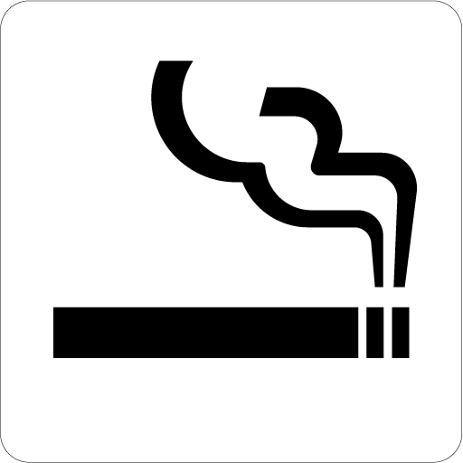
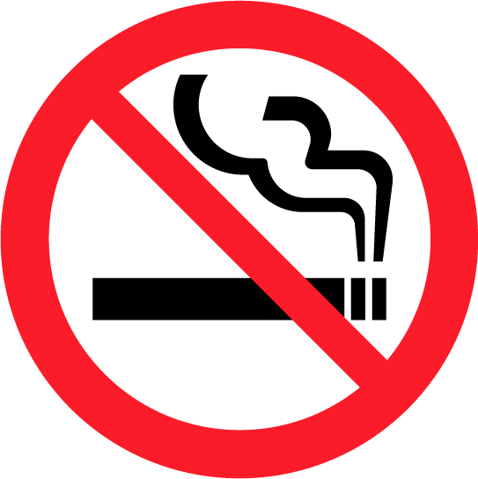
Smoking is not permitted inside the room./
Smoking is permitted inside the room.

Please smoke in the designated area. (xxxxxxxxx)
Please check whether the cigarette has been extinguished before putting it in the ashtray.
(6) Miscellaneous
・ Please do not loiter in the corridor or lobby outside of the facility.
・ Kindly contact the following number for any inquiries you may have and in the event of
equipment malfunction:
xxx–xxx–xxxx
・ Please lock the doors and windows when leaving the facility.
2. Access

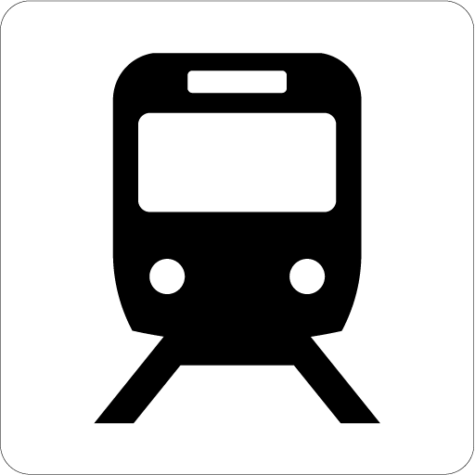
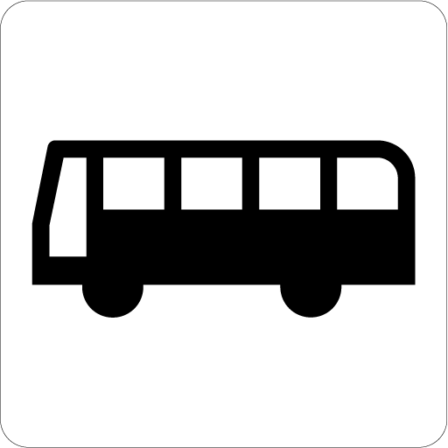
(1) xx is available as a means of transport. (x-minute walk)

(2) Please refer to the map for details on the route to the nearest station.

3. Showing Consideration for the Surrounding Area

(1) Noise
・ There are many private residences in the vicinity. Please show full consideration
for the people living in the surrounding area.
・ Kindly refrain from speaking and singing loudly, and playing music at a high
volume.
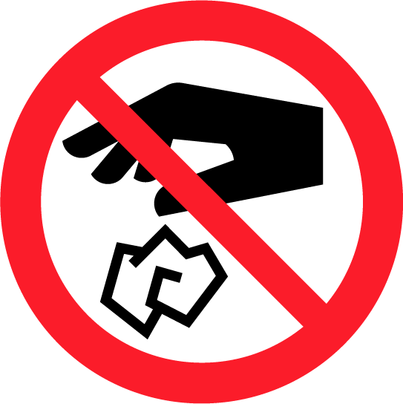
・ Please close the doors quietly.
(2) Waste Disposal
・ Please put your trash in the trash cans available within the facility.
・ Do not dispose of trash outside of the facility or near other private residences.
4. Fire Prevention

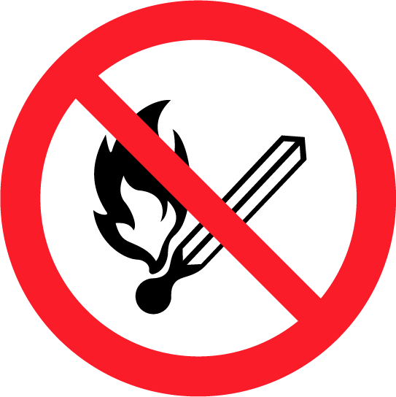
(1) Please do not leave the stove unattended when cooking.
(2) Please do not place flammable articles near cooking, heating, or lighting appliances.
(3) Please do not smoke on the futon or bed.
5. In the Event of Fire, Earthquakes, or Other Disasters

(1) Precautions During Disasters
・ Please call the fire department immediately if you discover a fire. (Tel. No. 119)
・ In the event of earthquakes, hide under a table or in a location where you will be
protected from falling objects.
・ Then switch off all cooking and heating appliances immediately.
・ Evacuate to a safe location by following the escape route on the map.
(2) Emergency Contact Numbers
・ Private Lodging Host (Private Lodging Management Agency): xxx–xxx–xxxx
Representative: xxxx
・ Fire Department/Ambulance: 119
・ Police Station: 110

*Please provide your address as well when contacting the emergency numbers.
The address of this facility is:
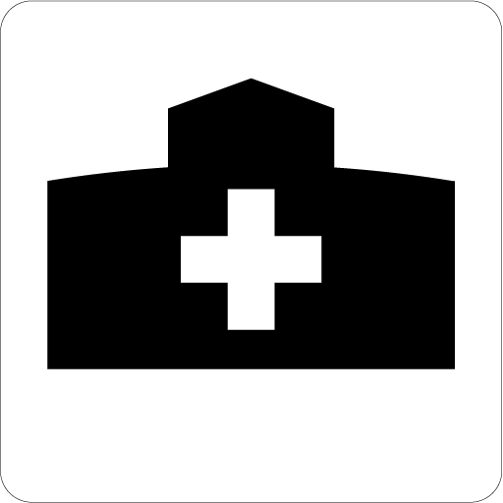
No. x (building name), x-x-x xx-cho, xx-shi, Tokyo.
(3) Nearest Medical Facility
(xxxx) Tel. No.: xxx-xxx-xxxx

